**Experiment No.1:**

**Aim:**

Familiarization of linux commands.

**CO2:**

Perform system administratioon task.

**Procedure:**

1. pwd – Prints the path of the current working directory.

**$ pwd**

**Output:**



1. ls -Used to list the files and directory.

**$ ls**

**Output:**



2 a. ls -R -Detailed view of subdirectory.

**$ ls -R**

**Output:**



2 b. ls -l - long listing of contents.

**$ ls -l**

**Output:**

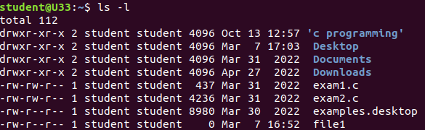

2 c. ls -a -Used to view hidden files.

**$ ls -a**

**Output:**



2 d. ls -al -To list the detailed information of files and directories along with hidden files.

**$ ls -al**

**Output:**

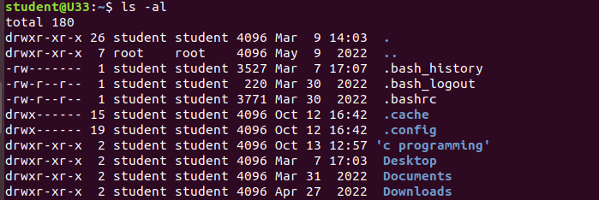

2 e. ls -t -List the files in the sorted order of last modified.

**$ ls -t**

**Output:**



3. mkdir – Allows user to create or make new directory.

**$ mkdir**

**Output:**



4. cd -Used to change the current working directory.

**$ cd binisha**

**Output:**



4 a. cd -- -To move one directory up.

**$ cd –**

**Output:**



5. history – To view the history and commands which we have been executed for a long time.

**$ history**

**Output:**

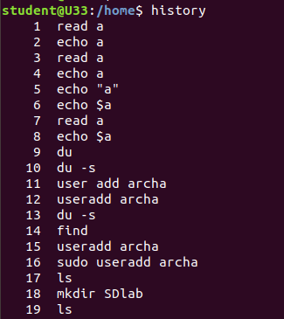

6. man -To learn and understand about different commands.

**$ man ls**

**Output:**



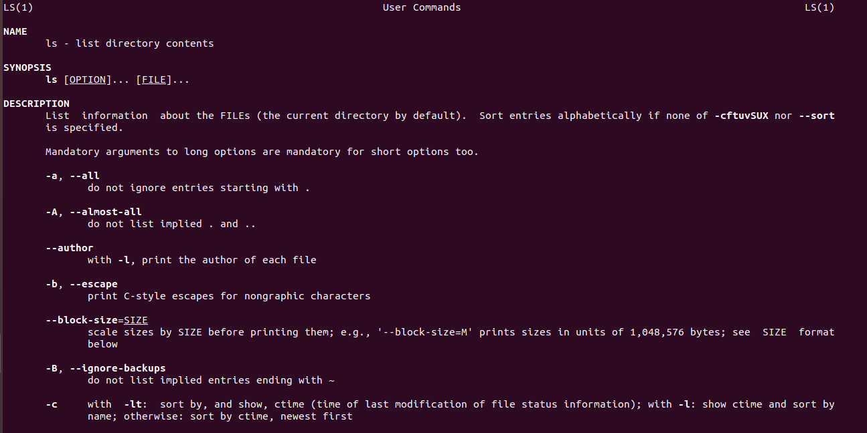

7. cat > – To create a new file.

**$ cat > first**

**Output:**

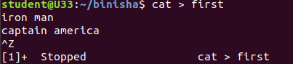

7 a. cat filename – To display content.

**$ cat first**

**Output:**

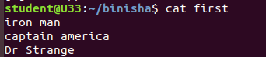

7 b. cat >> - To append content to the file.

**$ cat >> first**

**Output:**

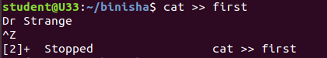

7 c. cat -n -To display the line number.

**$ cat -n**

**Output:**

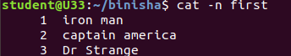

7 d. cat -b -Removing the empty line numbering.

**$ cat -b**

**Output:**

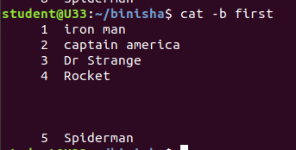

**Result:**

The program is executed successfully and the output is verified.